Map Alias
The Dinamica EGO Map Viewer now offers support for map aliases. By supporting map aliases, map viewer can assign more meaning to the information being displayed.
 | The aliases assigned by the map viewer are not used by other components of Dinamica EGO and have no impact on the simulations.

Setting up alias
- You need a loaded map to assign an alias, if you are unsure about how to load maps, please check Load a map.
- With a map loaded, click on the information icon () to show selected map information.
- A dialog will popup and you will be able to change the map alias by writing the new alias on the top text field.
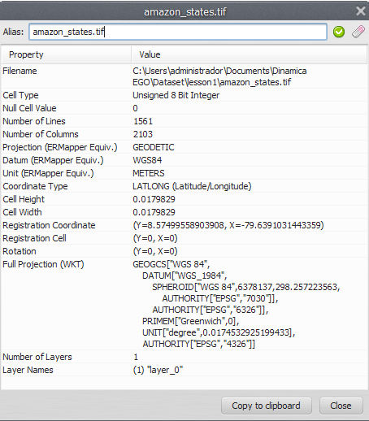
- The alias will be changed when you hit the “Apply map alias” () or “Restore original alias” () icons.
- You can also change the map alias by double clicking the map name/alias on the “Maps” window.
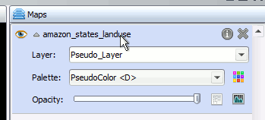
- After changing the map alias, you will see the new alias every time a map filename would be shown instead (legend, map information dialog, movie maker).


