Agents
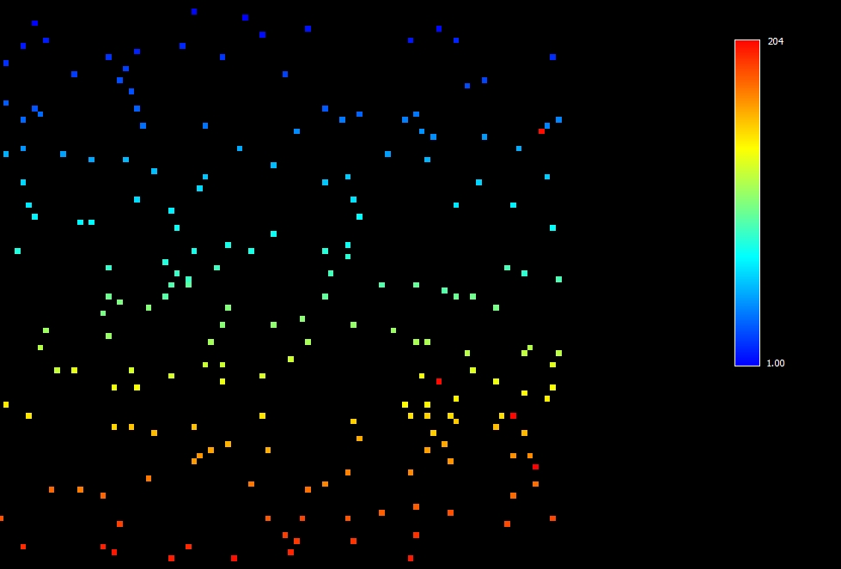
Agents can be defined as models for entities that are necessarily embedded in an environment with which they interact, being able to see it through sensors and act upon it through actuators (Russell and Norvig 1995). In this model the agents are rabbits represented by an image in which each pixel has agent’s identification value and indicates their spatial location.
Agents have the following attributes:
- Vision: value (number of cells) defining the range of vision of the agent used in the search for resources in the landscape.
- Resources spent on survival: value defining the amount of resources necessary to survive in one step of the model.
- Maximum absorption of resources: value defining maximum capacity for absorption of resources by the agent per step of the model.
- Resources spent on movement: value representing the amount of resources spent to move per step of the model.
- Average age for the death function: value that represents the average of a normal function that will determine the maximum age for an agent to live per step of the model.
- Type: represents the group which the agent belongs.
Constants | Values
Vision | 3
Maximum absorption of resources | 17, 19, 22 e 25 (according to the type)
Average age for the death function | 36
Resources spent on survival | 10
Resources spent on movement | 10
Initial amount of calories in agent’s stock | 50
Initial population of agents | 200
Maximum Birth rate | 0,0323

