Landscape
In this model the landscape is represented by an image in which the pixel values are the amount of resources.
The landscape map is an input that can be as the modeler desing it according to the study contex.
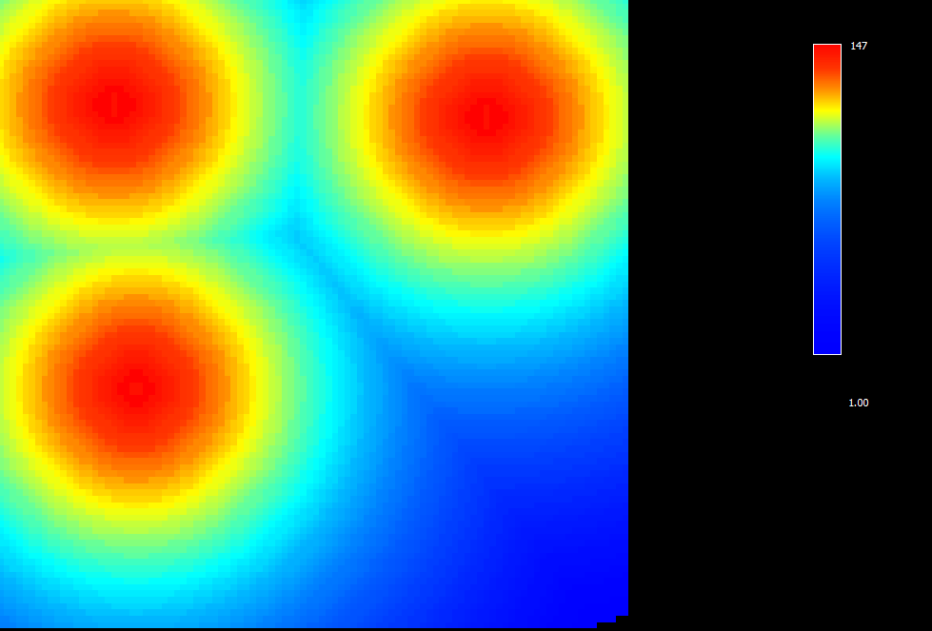
In this map, for example, the resources are heterogeneously distributed and there are 3 places with higher resources concentration.
The maximum capacity of resources in the cell is the attribute of the landscape. At each time step the landscape recovers itself considering its maximum capacity.

