Model Dynamics
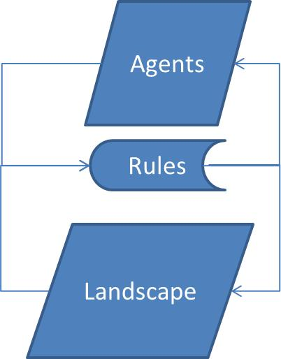
The model is composed by agents that interact with the environment which is a grid of cells with different amount of resources distributed. Agents and environment coexist through a set of behavior rules.
The agents have predefined genetic features (static attributes) as vision and metabolism, which determine the capacity to localize the resources and dawn them from the landscape, for example. Furthermore, the agents have dynamic and individual states as location and health. Landsacape also has attributes such as resources recovery.
Here you can find more details about the agents and landscape attributes and how the processes in the model works:
- Agents
- Landscape
- Processes

