Functor Library

Functor Library Panel
Shows functors and submodels.
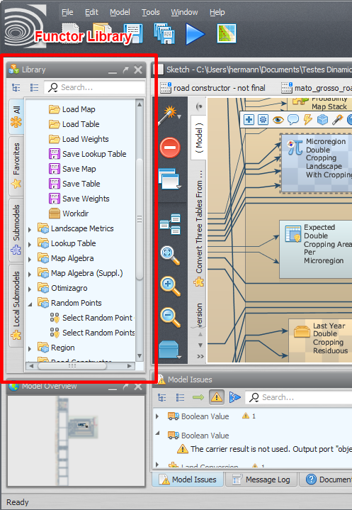Functor Library
The user can search for specific submodels and iteract with them, viewing the functor documentation, marking functors as favorites etc.
You can drag functor e submodels from the library to the model presentation area to use them in your model.

Functor Library Bar
Allows the user to interact with any functor or submodel available at the functor library.
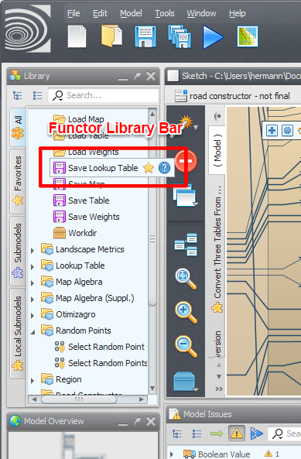Functor Library Bar
The options displayed on the bar depend on the kind of functor selected (regular functor, submodel, local submodel etc).

