Dinamica EGO Graphical Interface

Model Presentation
Main painel where all models are presented.
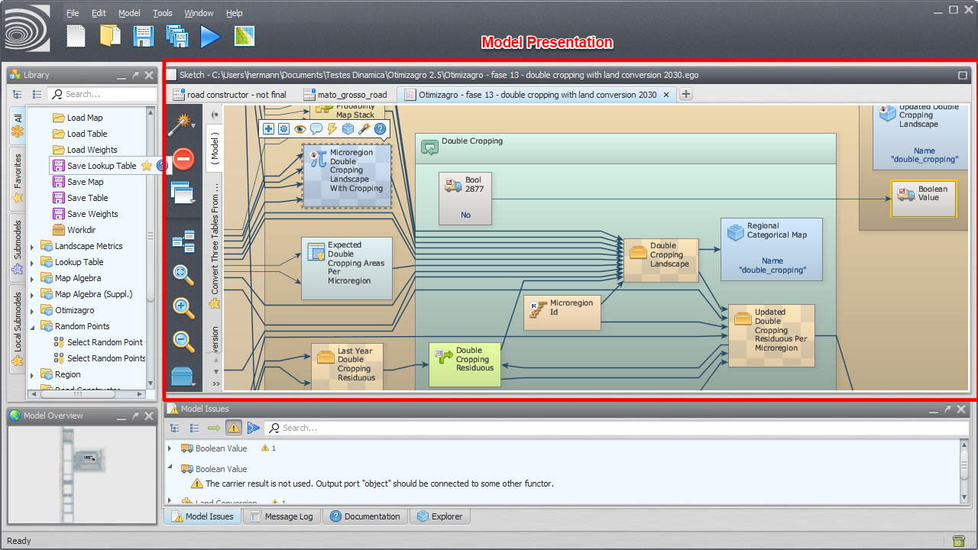Model Presentation
To open an existent model, drag the corresponding model script file from Windows File Explorer to the model presentation panel.

Model Selection Tabs
Tabs use to select the current model.
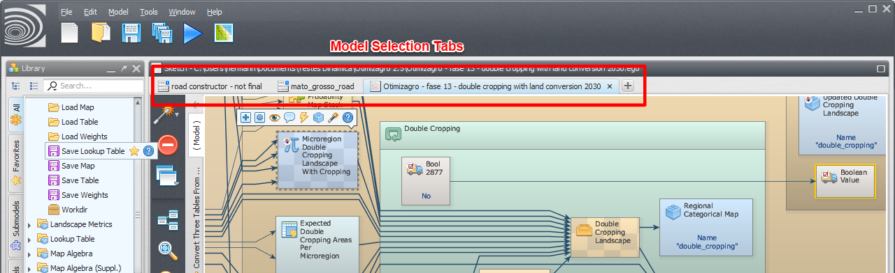Model Selection Tabs

Functor Action Bar
Allows the user to interact with the selected functor editing, commenting, inspecting etc.
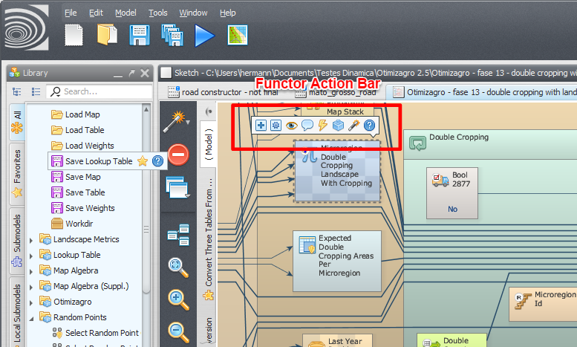Functor Action Bar
The operations available depend on the selected functor.

Connection Action Bar
Allows the user to interact with the selected connection.
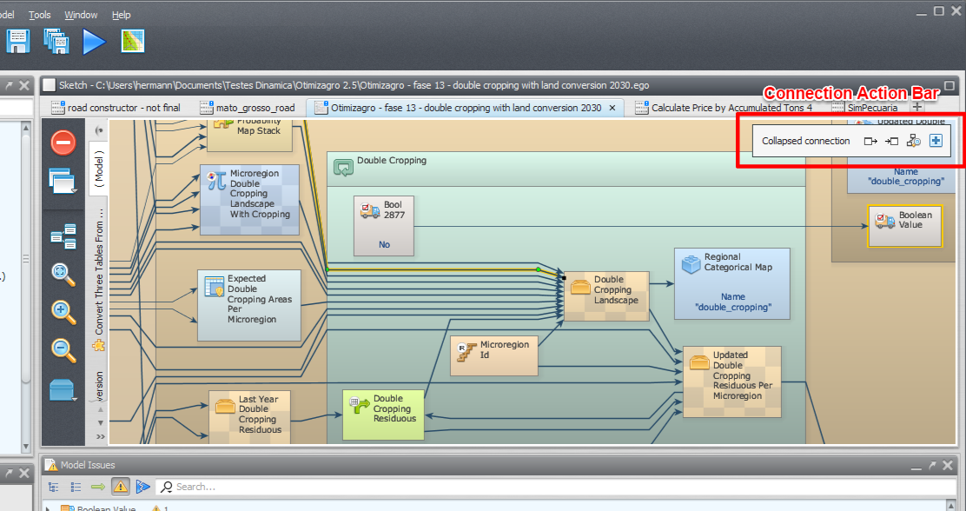Connection Action Bar
The following video illustrates the use of the connection action bar to navigate connections.

Local Submodel Selection Tabs
Tabs use to select the current local submodel or the main model.
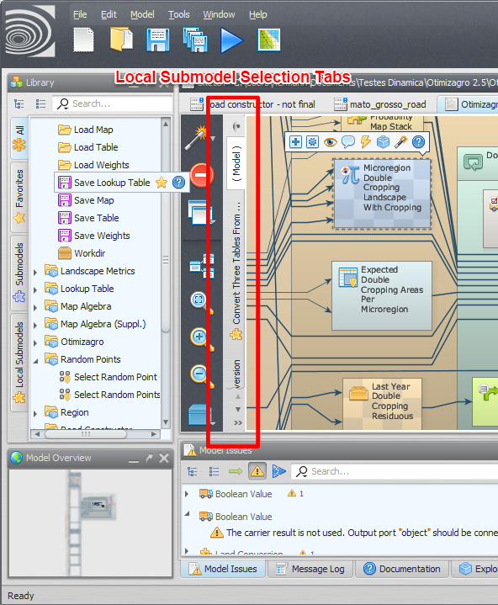Local Submodel Selection Tabs
The main model uses the name “( Model )”. The local submodels have custom names and also uses a custom icon.

