Dinamica EGO graphical interface

What will you learn?
- Dinamica EGO graphical interface
- Interface tools
Models are expressed in Dinamica EGO as a sequence of functors connected via compatible inputs and outputs. Hence data flow through these operators to produce a desirable outcome that represents the solution to a query on some environmental topic. The Dinamica EGO graphical interface is divided into 6 windows. From the top left clockwise they are:
1) the library,
2) the sketch,
3) the message log,
4) the bird view,
5) functor properties and
6) explorer tabs (fig. 2)
A model is designed simply by dragging functors from the library window and placing them on the sketch. The bird view provides a synoptic view of the model and is especially useful for large models that do not fit entirely on the sketch when shown at the default size. The shaded area on the bird view corresponds to the sketch window. Move the shade to zoom at a particular part of the model. The tree view provides a hierarchical view of the model allowing one to select or locate a functor and subsequently to edit its properties through the functor property window. In the lower part of the interface is the message log window, a space reserved for reporting textual messages showing results, errors, warnings, information and debug information. By default, the log text will output all information, but the user can change this just by pressing the button for the desired information level.
 | TIP: You can increase the performance of some models reducing the level of the log message. Another way to do this is using the log policy functor.
TIP: You can change the interface layout by dragging interface panels to new locations. The modified interface layout is automatically saved and reused next time Dinamica EGO is open. It is possible to restore the interface component layout to its original configuration clicking on Windows | Reset Window Layout.
TIP: you can resize or close windows. This may become useful as the model increases in number of functors. You just need to increase the sketch size at the expense of the other windows’ sizes.
On the bar at the bottom of the application window, you will also find the monitor window and the garbage collector tool that allows the user to reduce the memory dynamically allocated by Dinamica EGO. Allow the mouse to hover over the monitor window to amplify it.
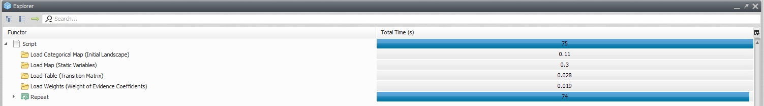
When a new version is available, a message will pop up on the interface corner window. Save your model and click on the icon below to reestart the aplication and applay the update automatically.
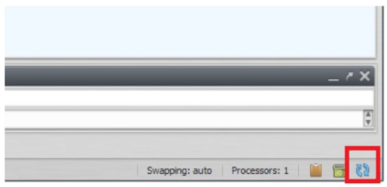
The sketch toolset permits connecting, editing, inspecting, selecting, moving functors, editing the functor ports, writing comments to a functor, organizing of the model layout, and exhibiting the model layout in different zooms
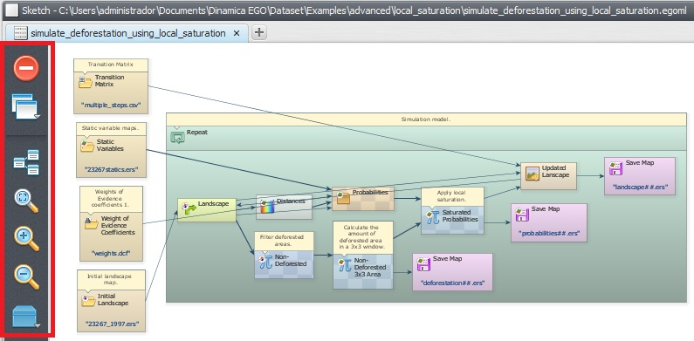
TIP: you can delete functors by selecting them with the hand tool and then pressing delete.
In the library window you will find the available functors organized in subsets according to their nature and application.
Finally, the icons on the menu bar are shortcuts to create, open, save a model, save model to a new file, work with model wizards, check model script operator integrity, check model script connection integrity, run a model, open the map viewer and work with submodels.
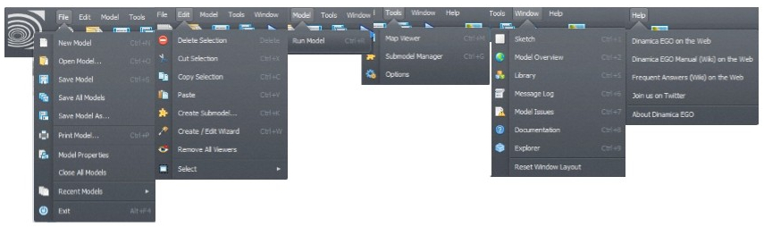
TIP: It is possible to open more than one instance of Dinamica EGO. This can be useful for example for comparing the structure of two models.
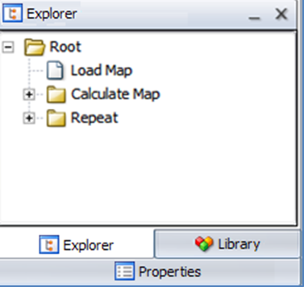
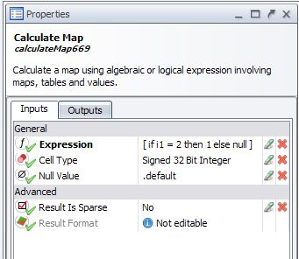
Once you start building a model, Dinamica EGO provides some features to help you navigate through the model. You can use the Explorer window to see a tree like representation of your model.
Clicking on a tree element will select it and enable editing via the property window
TIP: You can easily find any functor in the model, typing its name in a text box located at the right top of the interface. You can also perform a search by functor alias or comments.
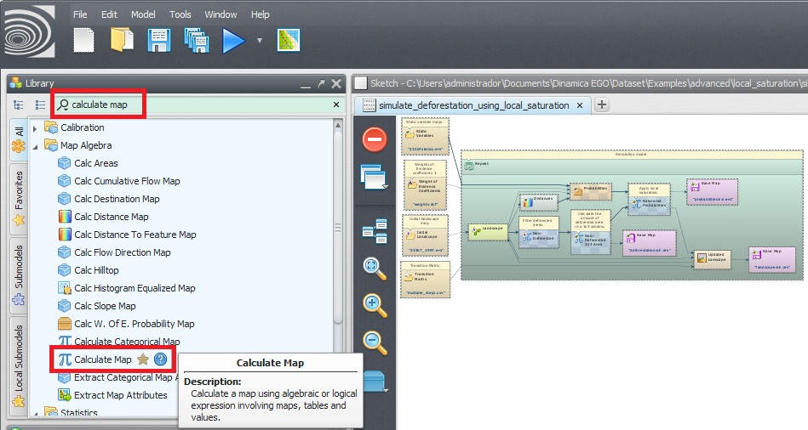
It is possible to give an alias to a functor in order to facilitate model understanding.
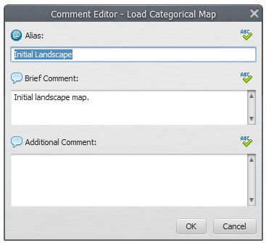
Click on any functor with the Edit Functor tool, go to comment tab and type in the alias.
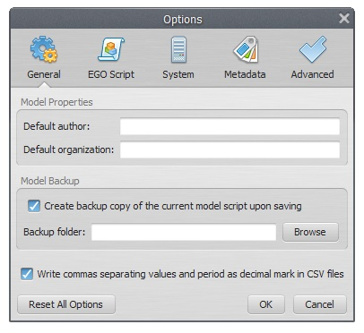
A new option window is available to enter model information and to set Dinamica EGO environment parameters. Go to Main menu Tools – Options:
The option window is divided into 4 tabs. The first tab is for filling in information on the model, setting message log, model backup, and appearance. The second is about settings of script writing , the “system” tab includes new versions update options and number of model scripts available options. And the last tab is for advanced options where raster map swapping can be disabled and you can define the number of processors to be used.
 | If you turn off map swapping, raster maps will be kept in virtual memory. Beware that large data models may cause “Allocation failed” and crash thereof.
 | To see the list of functors available in Dinamica EGO:  - use the Dump Functor list, located at the Help menu. A list of functor is displayed inside the log window;  - go to Help Contents or Functor List to get a detailed description of each functor and its algorithms

