Using the concept of region

What will you learn?
- How to use the concept of Regions
- Functors:
- Region manager
- For Each Category
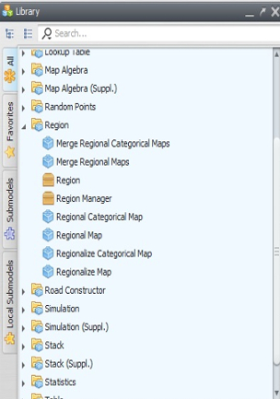
An alternate way to solve the exercise of the previous lesson is by means of Region. This subset of functors permits division of a map into several regional maps, which can be input for separate models or submodels, whose parameters are customized for each map’s region. Let’s adapt the previous model to use the concept of regions. First open the Region Tab in the library window.
These functors can be combined to produce regional maps and submodels, as well as to merge the regional maps into a single map after a processing is performed. In this lesson you will learn how to retrieve the area of the remaining forest for each state; as a result each regional map will correspond to a state area. Open the model completed in the previous lesson. Select the functors within the container Repeat with the Hand tool and then drag them out of Repeat.
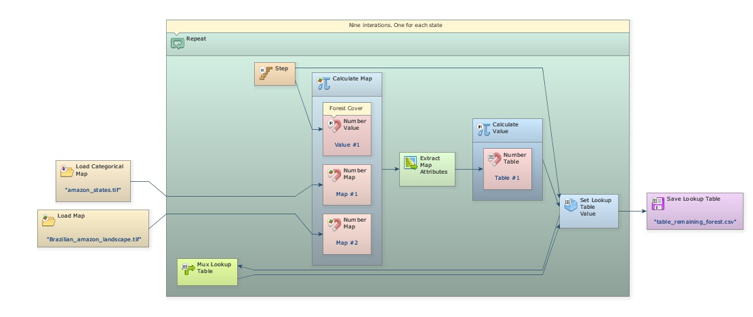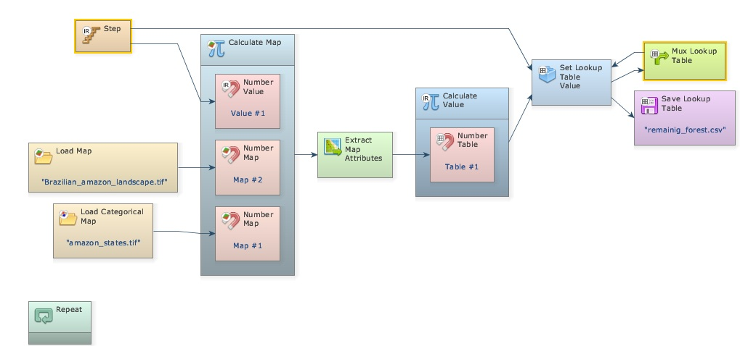
 | TIP: Use Crtl + right button to keep continually selecting the functors, this will avoid selecting Repeat as well. The functor Repeat will shrink.
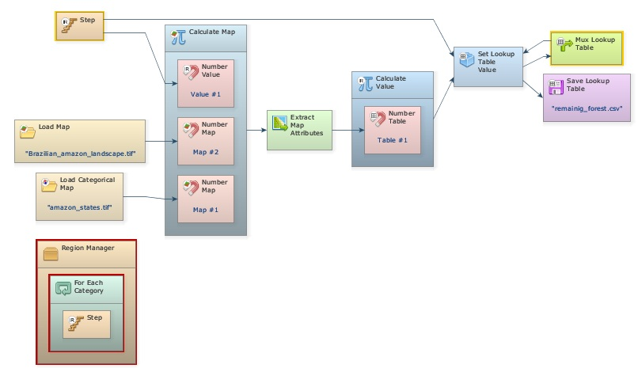
Delete the container Repeat and place the containers Region Manager from the Region tab and For Each Category from the Control tab. Place the latter within the first.
Region Manager manages the regionalization process, while For Each Category replaces the Repeat making the model iterate for each category present in the categorical map used to define the regions, in this case the map of the Brazilian Amazon states.
TIP: While Repeat iterates sequentially, For Each Category iterates according to the map categories, which do not need to be sequential.
Now select all functors, except the input and output maps, and place them within For Each Category.
TIP: it is easier to select everything to be placed within For Each Category and then to take only Load Map and Save Map out of it.
Now break the link between Load Categorical Map and Calculate Map (use the Remove Items tool and click on the arrow connecting both functors); next, connect the first to Region Manager and to For Each Category too. This map will control the regionalization process splitting the other maps into several regions according to its cell classes or categories through the functor Regionalize Map. Drag this functor and place it within For Each Category, break the link between Map “brazilian_amazon_lanscape.tif” and Calculate Map and finally connect the first to Regionalize Map.
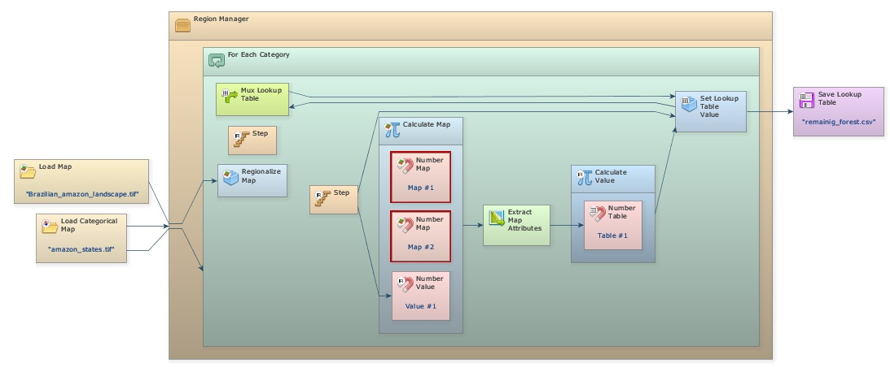
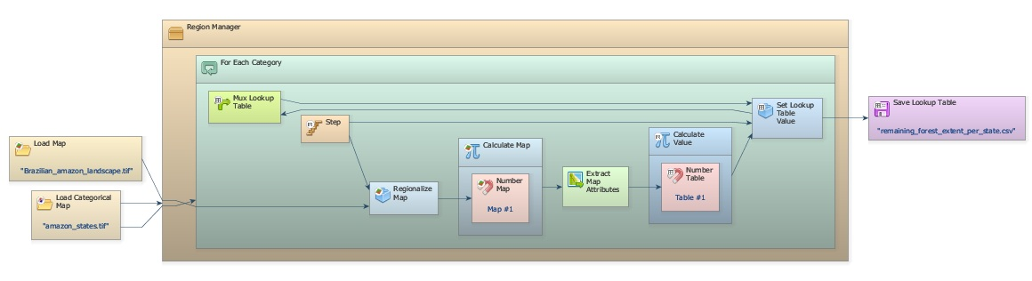
Note that there are two Number Map functors disconnected within Calculate Map. You do not need the Map # 2 and Value # 1 anymore, so delete them. Now connect Regionalize Map to Map # 1. Open the Table functor and change the file name to “remaining_forest_extent_per_state”. Make sure it will be saved into folder Region_Lesson.
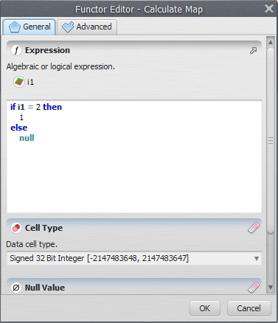
At a last step, you will need to modify the Calculate Map. Open it with Edit Functor. Write: if i1 = 2 then 1 else null. Remember that “2” represents forest.
Finally save the model as a new file “my_calc_forest_remaining_per_state_using_subregions.xml” into folder Region_Lesson. Test the model integrity, and if everything is O.K., click on the run button.
Compare this model’s output with the result from the previous lesson. Do they match? Can you explain how this model works?
Observe that you did not need to segregate the information per state in Calculate Map because Regionalize Map already did it.
TIP: the region approach is a helpful way to break the map into several subsets either to customize a submodel, for example to run with different parameters per country, state or county, or to optimize the memory usage as the model does not need to handle all the map cells for a specific calculation or processing, but only the cells selected from a region per time
Now let’s move on to more advanced spatial analyses.

