What is New in Dinamica EGO 5
Dinamica EGO 5 bring several groundbreaking improvements and changes in several areas:
Execution
- The parallel execution system was rebuilt from scratch making this the fastest Dinamica EGO ever! The new system uses a fixed number of execution threads (called workers) with work stealing to improve load balancing, and also features a faster logging infrastructure. As the result, all models run in parallel, when possible, including:
  - Independent functors are run in parallel;
  - Independent loop steps are run concurrently;
  - Pieces of maps are loaded in parallel.
- Many internal optimizations.
- Images are manipulated in parallel even when they are too big to fit in memory.
- New option to control how memory allocation for maps work.
- Certain functors can have their execution accelerated using GPUs (accelerators).
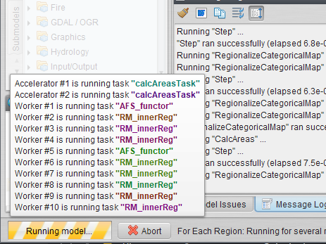
Internationalization
- Proper manipulation of file paths, comments and functor alias in languages other than English, even if the interface still only available in English.
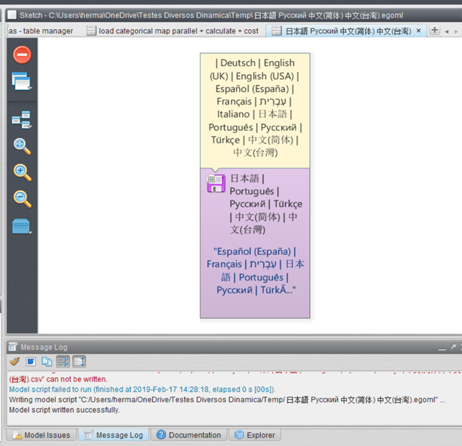
Integration
- R: It is now possible to install packages even when R is installed using the Enhancement Plugin. Just replace the typical import statement 'library (NAME)' with 'dinamicaPackage(“NAME”)' when importing packages from your scripts. By doing so, packages will be automatically downloaded and installed, if necessary.
- Python: Python can now be used to create functors, via Calculate Python Expression as part of the models. It is now possible to install packages by using 'dinamica.package(“NAME”)' when importing packages. Similarly to the R packages, the Python packages will be automatically downloaded and installed from the PIP repository, if necessary. Packages can also be installed from custom locations.
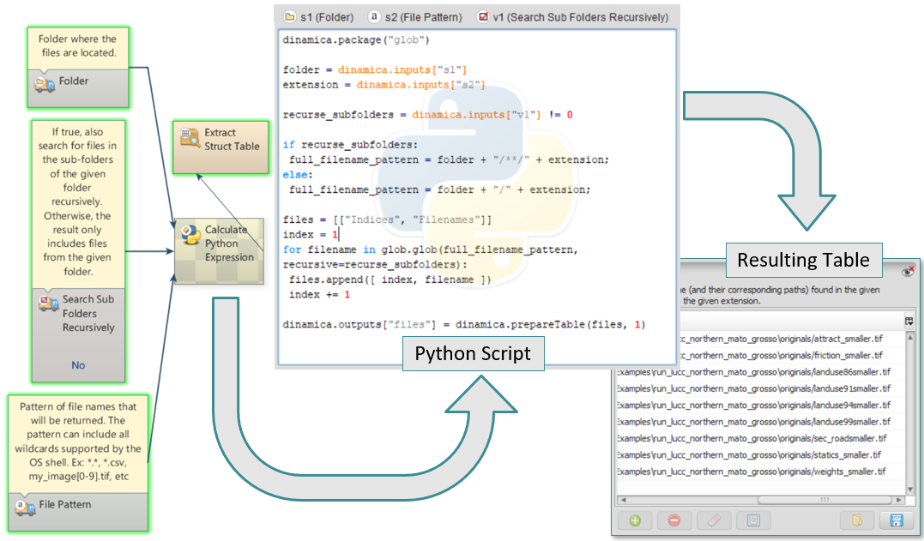
Portable
- Windows version can be used without having to be installed (portable version). However, the full installer is still recommended for easier deployment and for a better overall experience.
Submodels
- Submodels and functors can now use groups in the functor library with multiple levels.
- Submodels can place inputs in custom tabs (other than the default or advanced tabs).
- Submodels are loaded “lazily” when the application starts. As the result, Dinamica tends to initialize very quickly, even when dozen of submodels are installed.
Miscelaneas
- More uniform control of settings (variables and registry)
- Virtualization Off is no longer available.
- New command line tool.
- Hundreds (maybe thousands) of bug fixes.
Platform
- Dinamica EGO 5 is 64-bit only application.
- Compiled using the latest compilers.
- New building infra-structure.
- Available for Windows, Linux and Mac.

